Options for Managing Courses that are Preferred or Recommend (Sometimes Hidden)
Approved by the Undergraduate Deans
July 8, 2025

Background: Several degrees have courses that may be used to fulfill requirements that are not the recommended or preferred course. However, if the student has already taken the course, it would fulfill the requirement. In other cases, there are courses that may fit a particular student’s need because they are heading for a particular post-undergraduate experience such as medical school or veterinary medicine.

One of the challenges is balancing the need to be transparent so that students know about these options while steering the majority of the students down the preferred path to earn the degree. To this end, below are three approaches that are meant to strike that balance while avoiding “hiding” classes so that students can’t see them on the catalog/degree audit.

Departments may use any or all options.
Some of the AU’s are already deploying these approaches.

Option 1 - Labeling Courses as “Recommended” or “Preferred”
Below are illustrations showing how this looks on the audit and in the catalog.
Audit
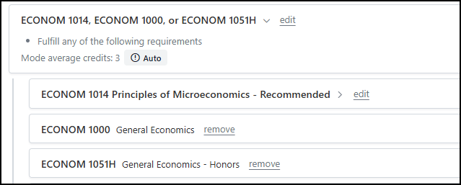
Catalog
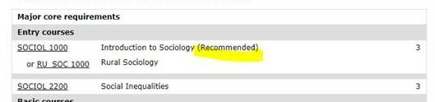

1 | P a g e

Two guiding principles will ensure that labeling adheres to the “simple, transparent, and consistent” tenets:
- All AUs/departments will use the same wording in the catalog to describe the options:
  - Recommended
  - Preferred

- Degree Audits will use the same wording as the catalog. e.g., if a course appears as Recommended in the catalog, it would also appear as Recommended in the degree audit report.

Option 2 – Offering “Options” or “Tracks”
Students can choose from various paths that ultimately lead to the degree. There could be options or tracks for “Pre-Vet Med” or a “Pre-Med,” etc. Once chosen for the student the option or track is part of the degree audit. These will be spelled out in the catalog. This approach works well when there is a subset of students who routinely want to follow an alternative, acceptable path to the degree.

Students or advisors can select a track. The set of requirements contained in the track is then incorporated into the degree audit; the audit will not “complete” without completion of a track.

Tracks are not part of the myZou official academic record. They do not print on transcripts.

Option 3 – Hidden Courses or Requirements
If listing possible course options for a requirement would unnecessarily clutter the audit report, the courses may be hidden.

Courses that may be hidden are “by contract” courses, discontinued courses (e.g. CHEM 1320) and transfer courses that lack an exact articulation match (e.g., BIO_SCI ELECT**).

Courses may also be hidden when they have attributes. For example, attributes are used for General Education requirements rather than displaying every possible course. This keeps the information displayed in the two places in synch and prevents the audit reports from being excessively long (some Gen Ed requirements accept several hundred courses). Eligible courses with the appropriate attributes will appear in a sidebar in the audit for students to review and select.
2 | P a g e

