Step by Step Instructions
- Launch College Scheduler
- Optional: Review Home Page Filters
- Add Courses
- Optional: Course Options
- Generate Schedules
- Optional: Add Break
- View Potential Schedules
- Reviewing Potential Schedules
- Optional: Section Lock
- Send to Shopping Cart
- Register
- Optional: Edit or Drop Classes

Launch College Scheduler
Once College Scheduler is launched, the main landing page is loaded with custom configuration settings specific to the institution (filters, custom text, colors, logo, etc).
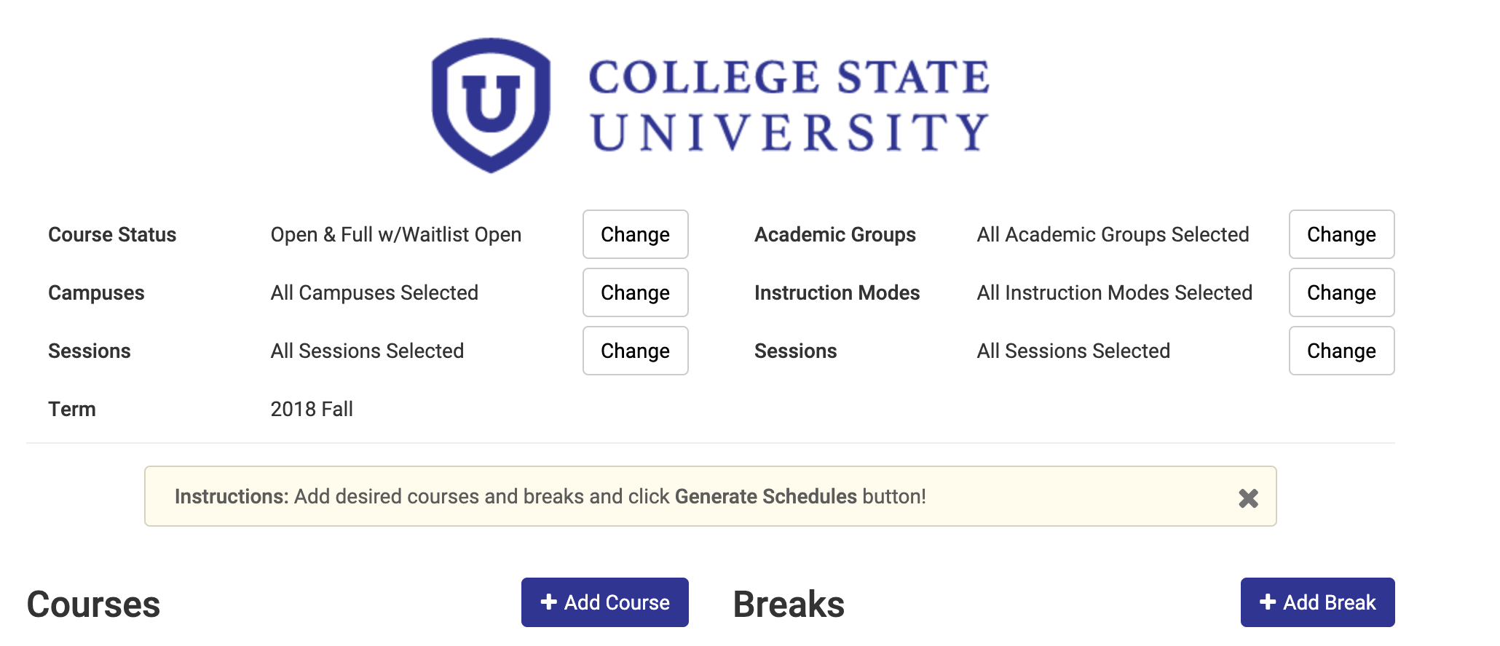

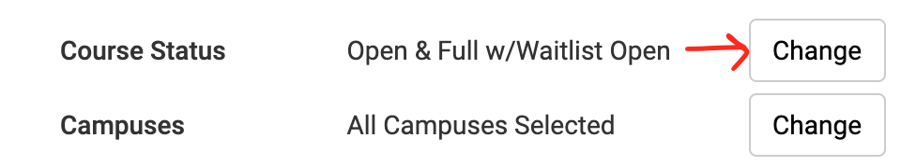
- Optional: Home Page Filters
Click Change to edit any filter settings like Course Status, Campus, Parts of Term, Instructional Method.
- Custom filters are unique to each institution’s course catalog setup.

- Add Courses
When adding courses for your selected term, taking into account the filter settings, it will display the appropriate course offerings. There are typically a few ways to search for a course.
Click the Add Course button to start.

Optional: Course Options
The course Options button allows the selection of specific sections, review section information, and to see if any sections are Disabled due to the filter settings. Disabled sections will not appear in the set of potential schedules to review.
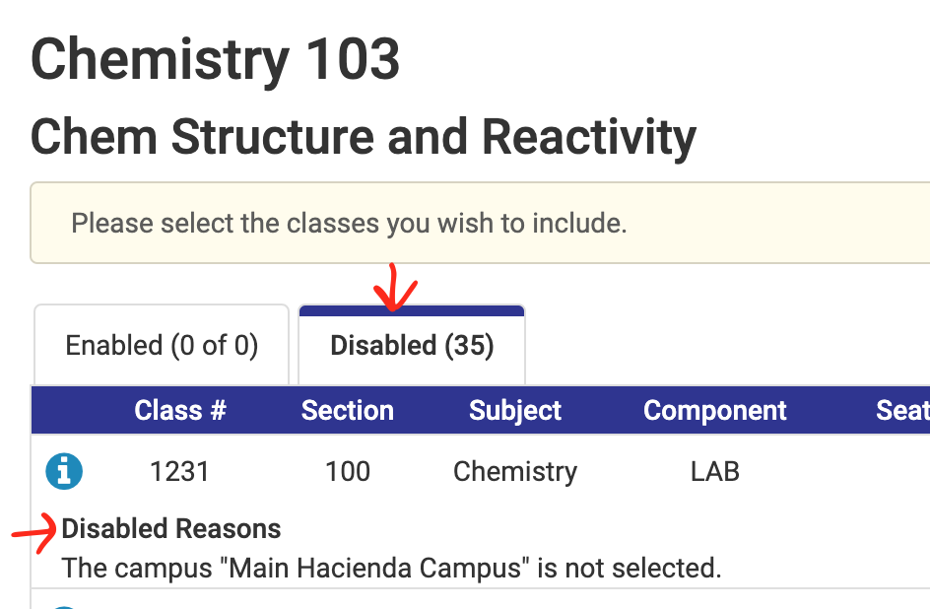
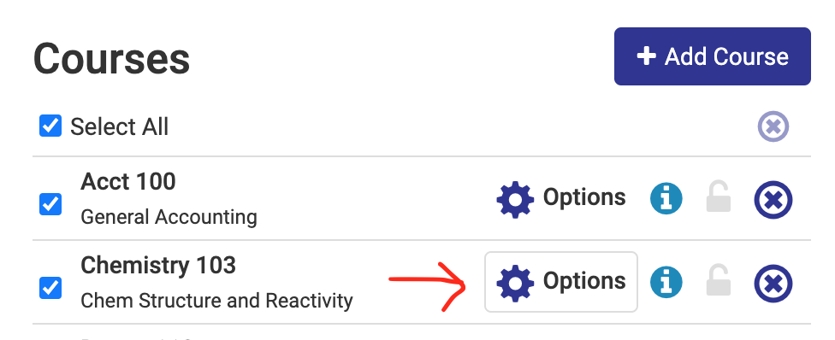

- Generate Schedules

Once the courses have been added, and any specific options have been selected, hit the Generate Schedules button to show all the potential conflict-free schedules.
- If there is a conflict detected, there will be a notification with the specific courses that are the cause of the conflict and the student will know what to adjust.
- Many times, there will be a large number of potential schedules; too many to efficiently review. This is where the Add Break functionality comes into play.
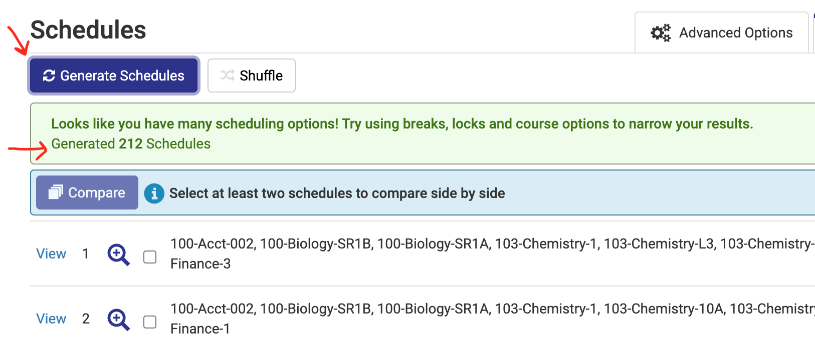

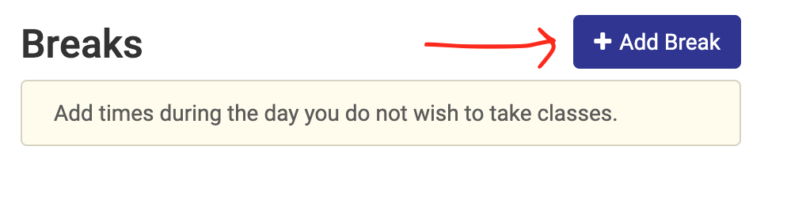
Optional: Add Break
Click the Add Break button to add in any time of the day, any day of the week where one does not wish to take classes

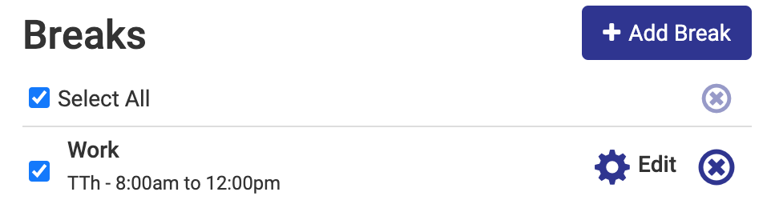
Students today have work, families, and many added responsibilities outside of school. When adding a break to the Schedule Planner, it allows the student to find a balance between school and life - further supporting students’ persistence.

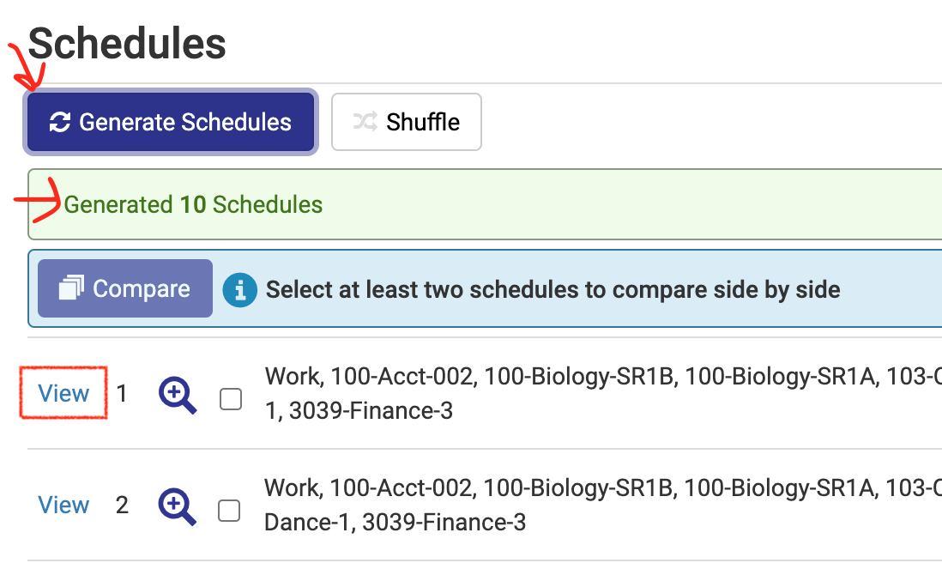
View Potential Schedules
Click on the View button to review the schedule.
- If a break has been added, click Generate Schedules again to bring in that new data. Most of the time it will greatly decrease the large number and narrow down to the ones that best fit the student.

- The Magnifying Glass button gives a high-level visual of that potential schedule.

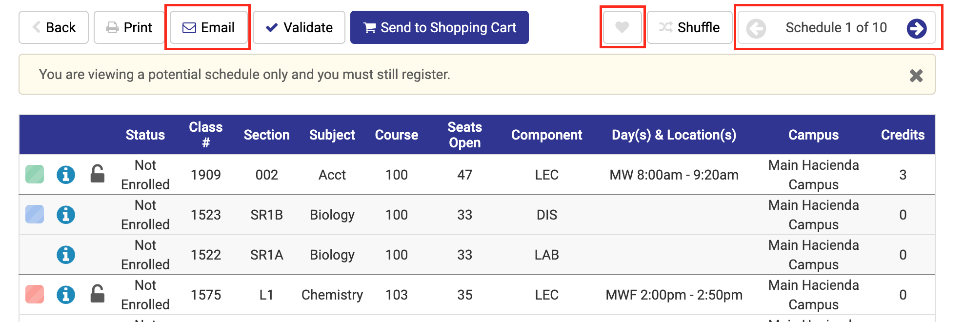
Reviewing Potential Schedules
There is a total count of schedules in the top right corner that can be clicked through to review the differences between them.
- To save a schedule, click the Favorite [Heart] button.
- To email a schedule to an Advisor, Parent, Employer, etc. a student can click the Email button to do so.
- Different visuals of the schedule can be seen below the potential schedule. This allows one to better gauge that potential schedule with the Week-by-Week and a One-Week view.

Optional: Using the Section Lock
If there is a particular section that is wanted in all potential schedules, one can push the Unlock symbol, to turn it into a Lock symbol and the Scheduler will automatically narrow down the results to only include schedules that have that one specific section which was locked.
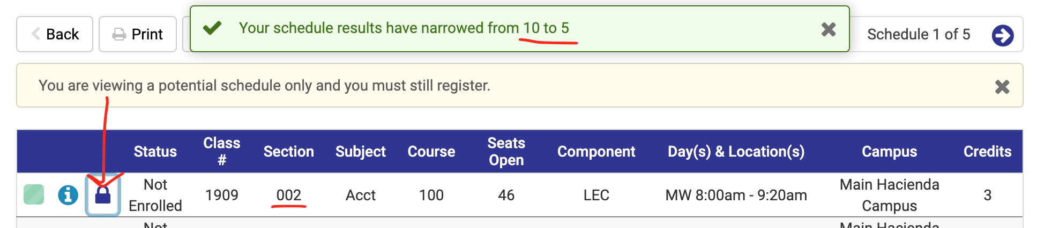

Send to Shopping Cart
From the View Schedule screen, click the Send to Shopping Cart button to begin registration.

- Register
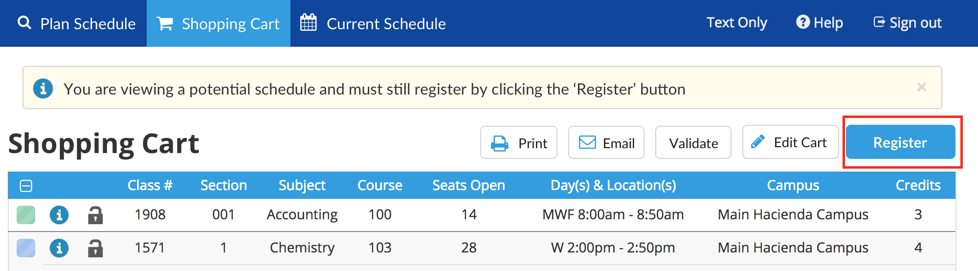

Click the Register button to enroll in these classes in the Shopping Cart.
- Courses can, and should, be added to the Shopping Cart prior to a student’s registration window. The potential schedule can then be ready to go when that time comes.
- The actions taken at this point will reference back to the institution’s SIS and validate any items that have been custom configured.

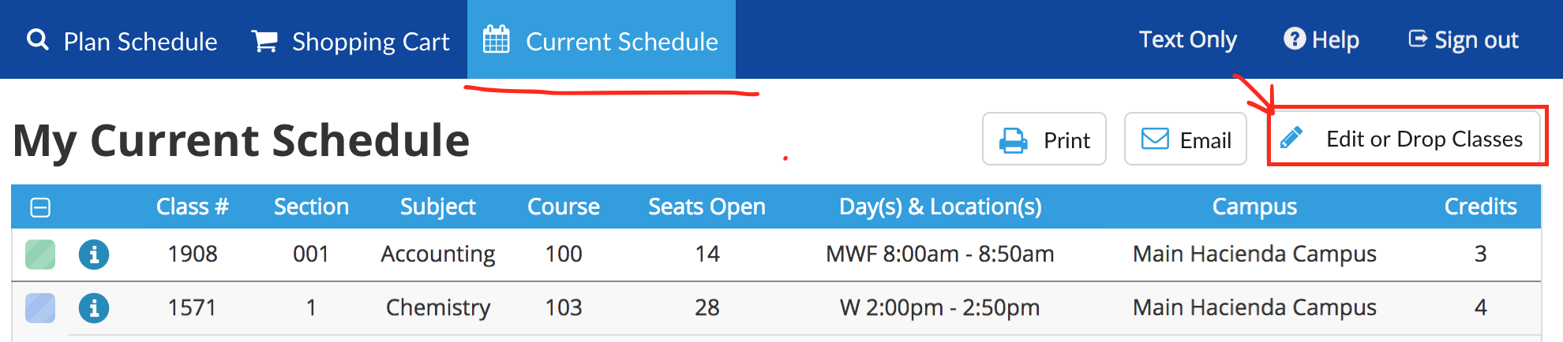
Optional: Edit or Drop Classes
Using the Edit or Drop Classes button, a student can drop a course from within the Schedule Planner; there is not any need to go back into the SIS to complete this task. If a course has variable units or if it can be selected as Pass/No Pass, that option is available here as well.

